COMMANDS OF SQL:

CREATE TABLE STUDENTNEW1(

Reg_No NUMBER(20), Names VARCHAR(38),Date_Of_Birth DATE

);

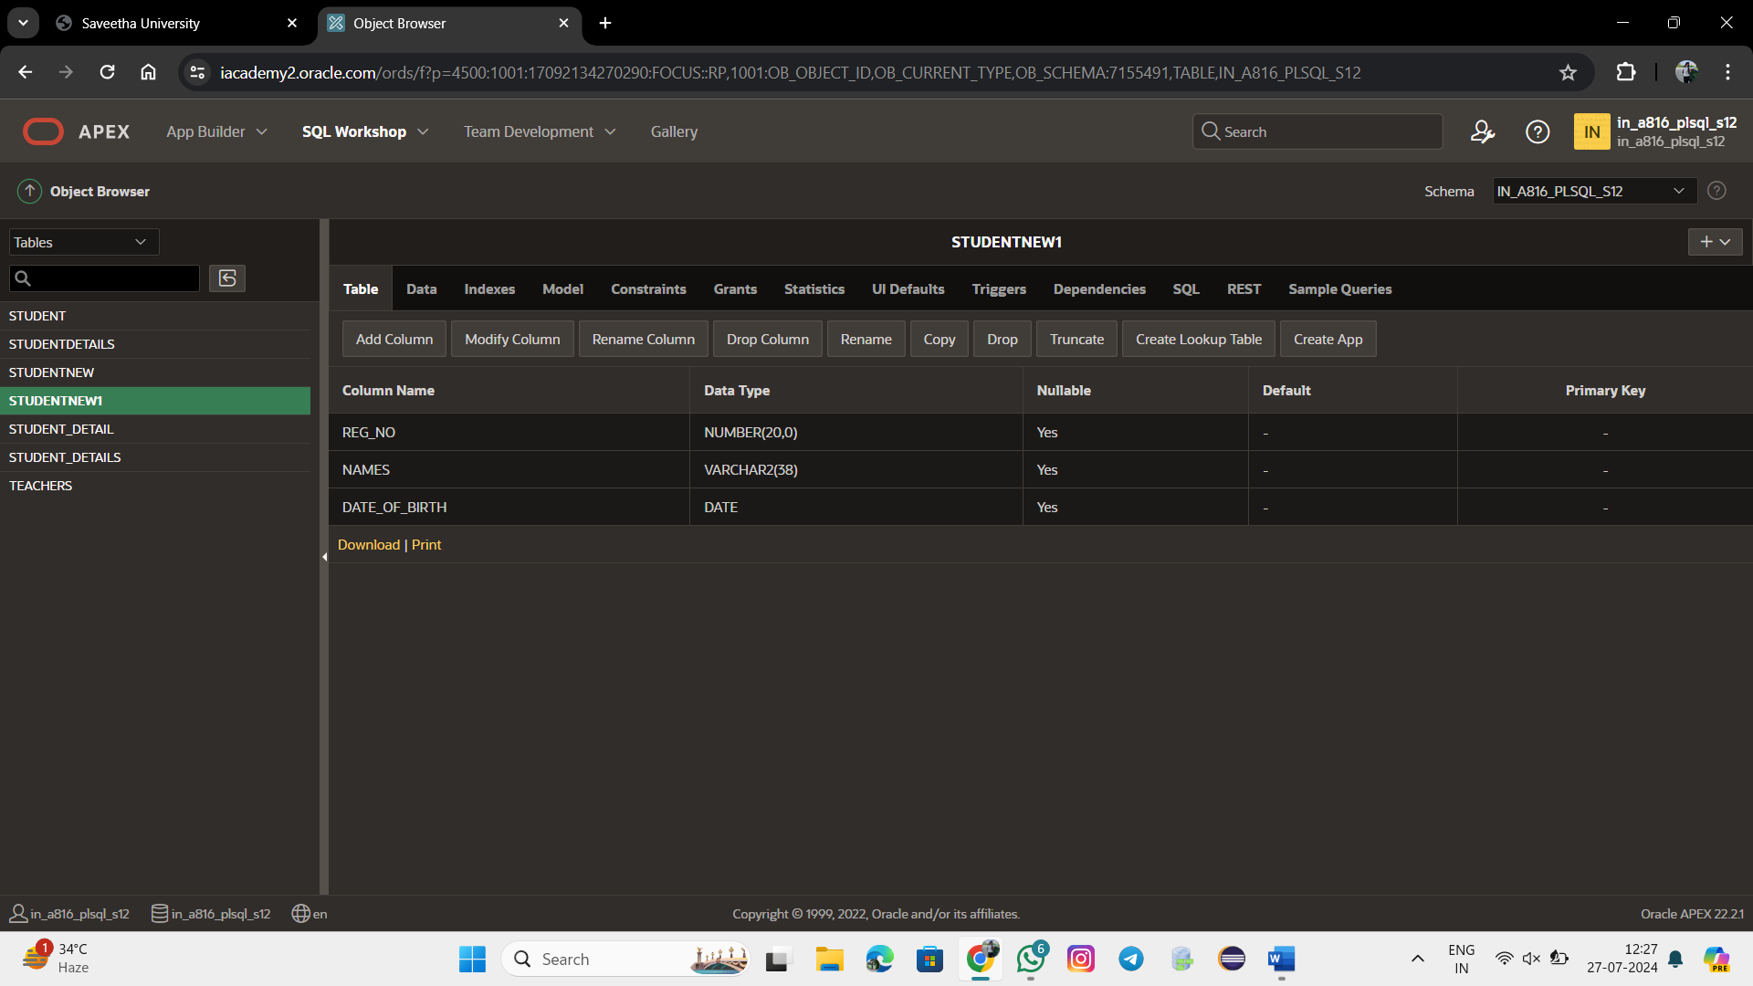

ALTER TABLE STUDENTNEW1

ADD Blood_Group VARCHAR(20);

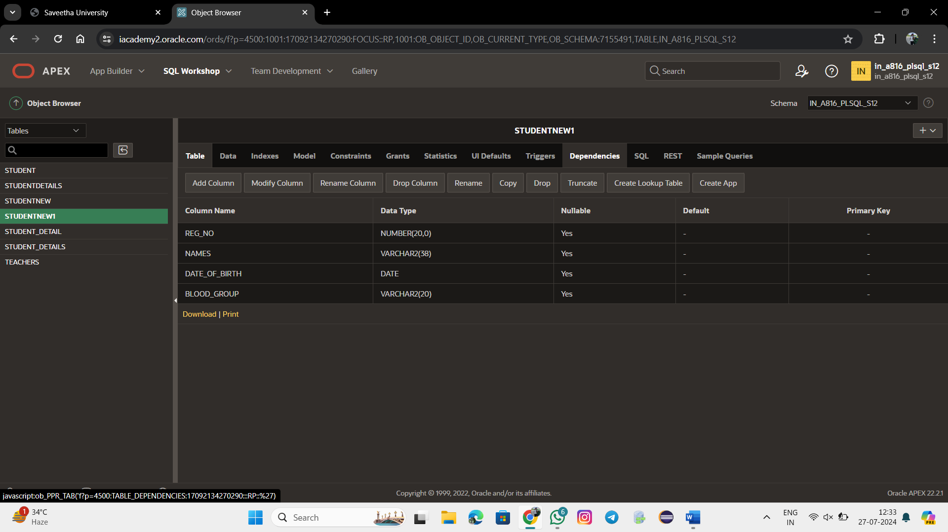

ALTER TABLE STUDENTNEW1 ADD PRIMARY KEY (Reg_No);

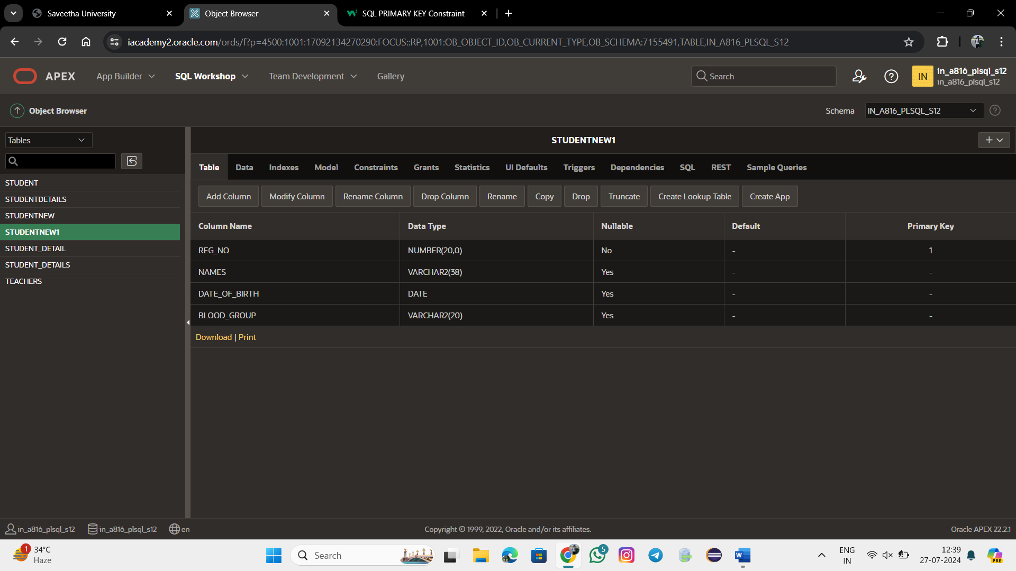

ADDING NEW COLUMN AND DELETEING THE COLUMN:

ALTER TABLE STUDENTNEW1

ADD User_ID NUMBER(20);

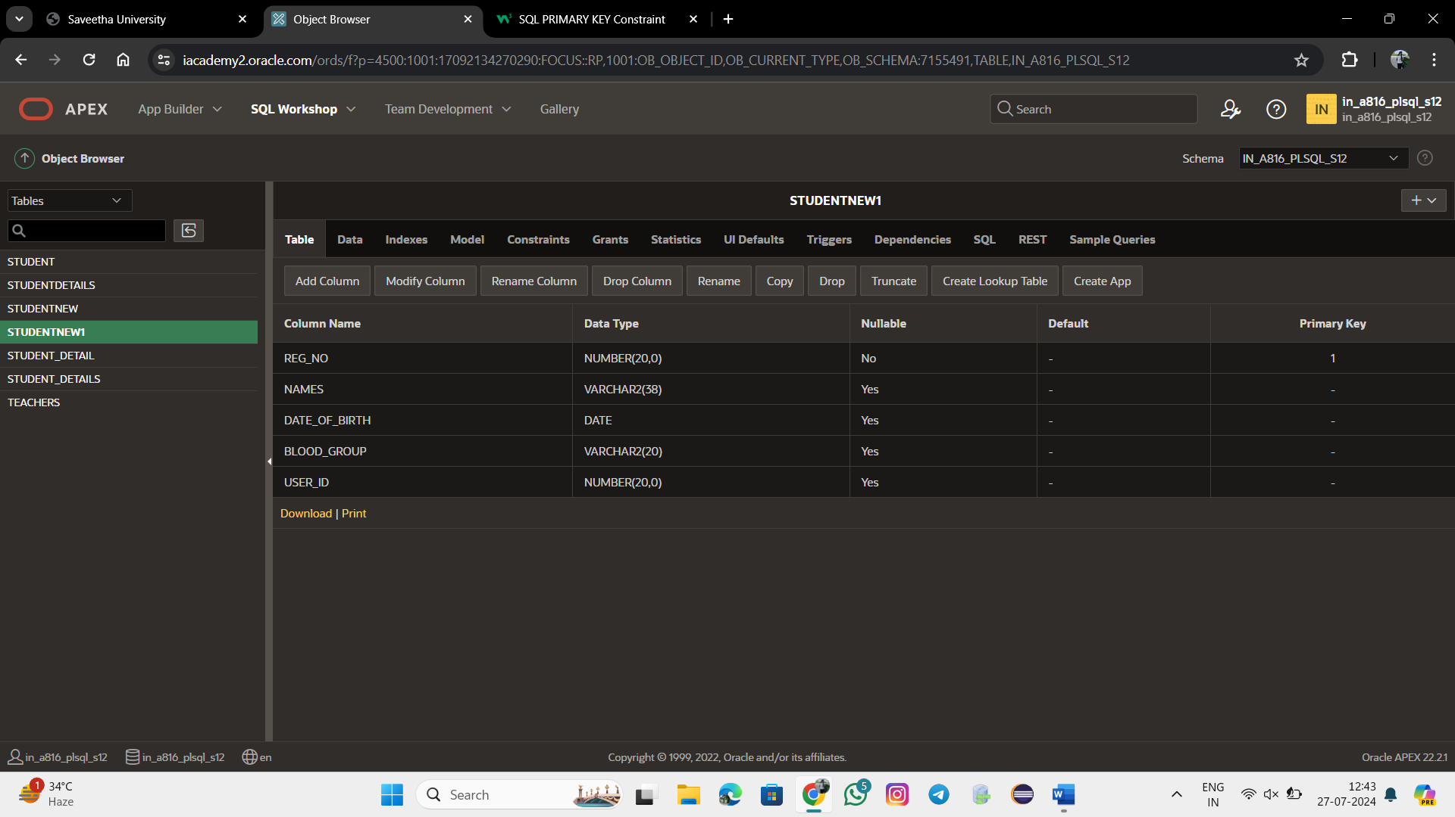

ALTER TABLE STUDENTNEW1

DROP(User_ID);

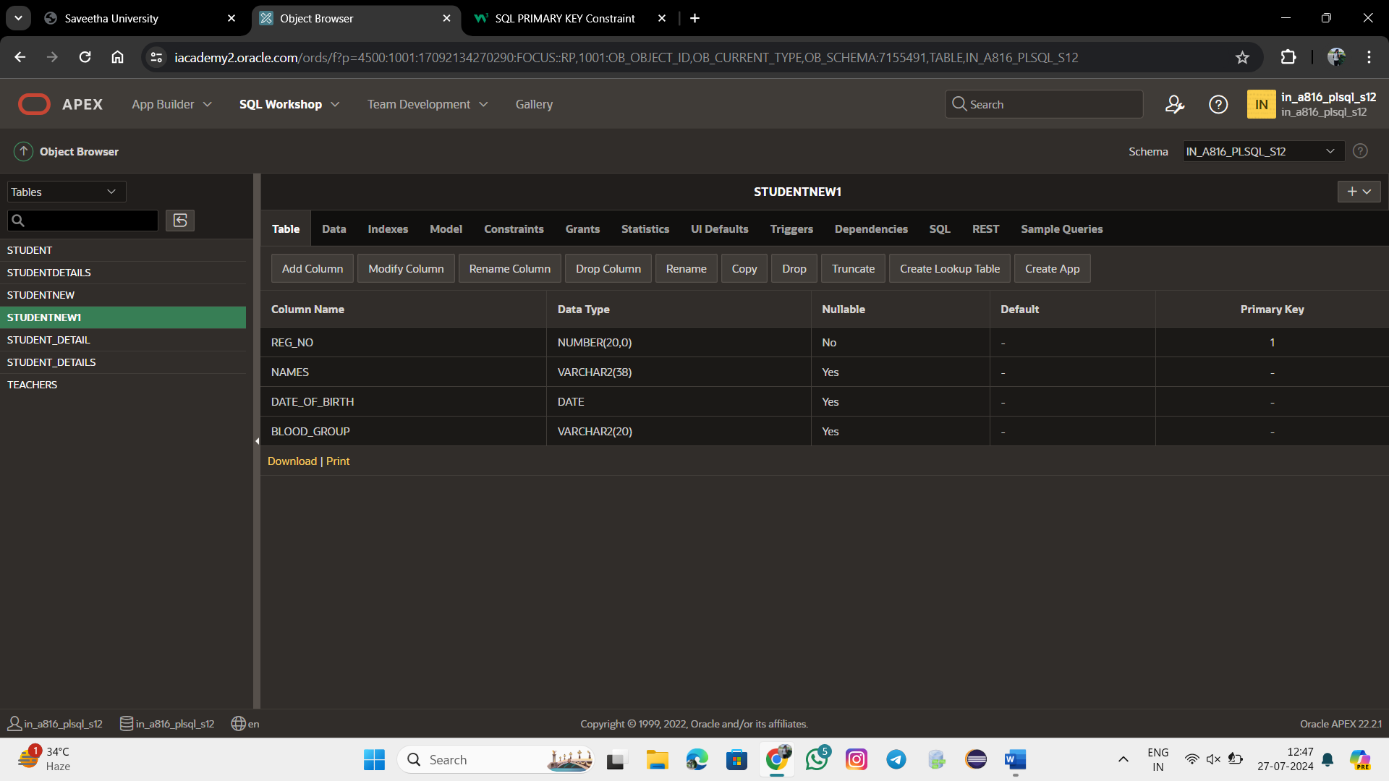

ALTER TABLE STUDENTNEW1

RENAME COLUMN Reg_NO TO Register_No;

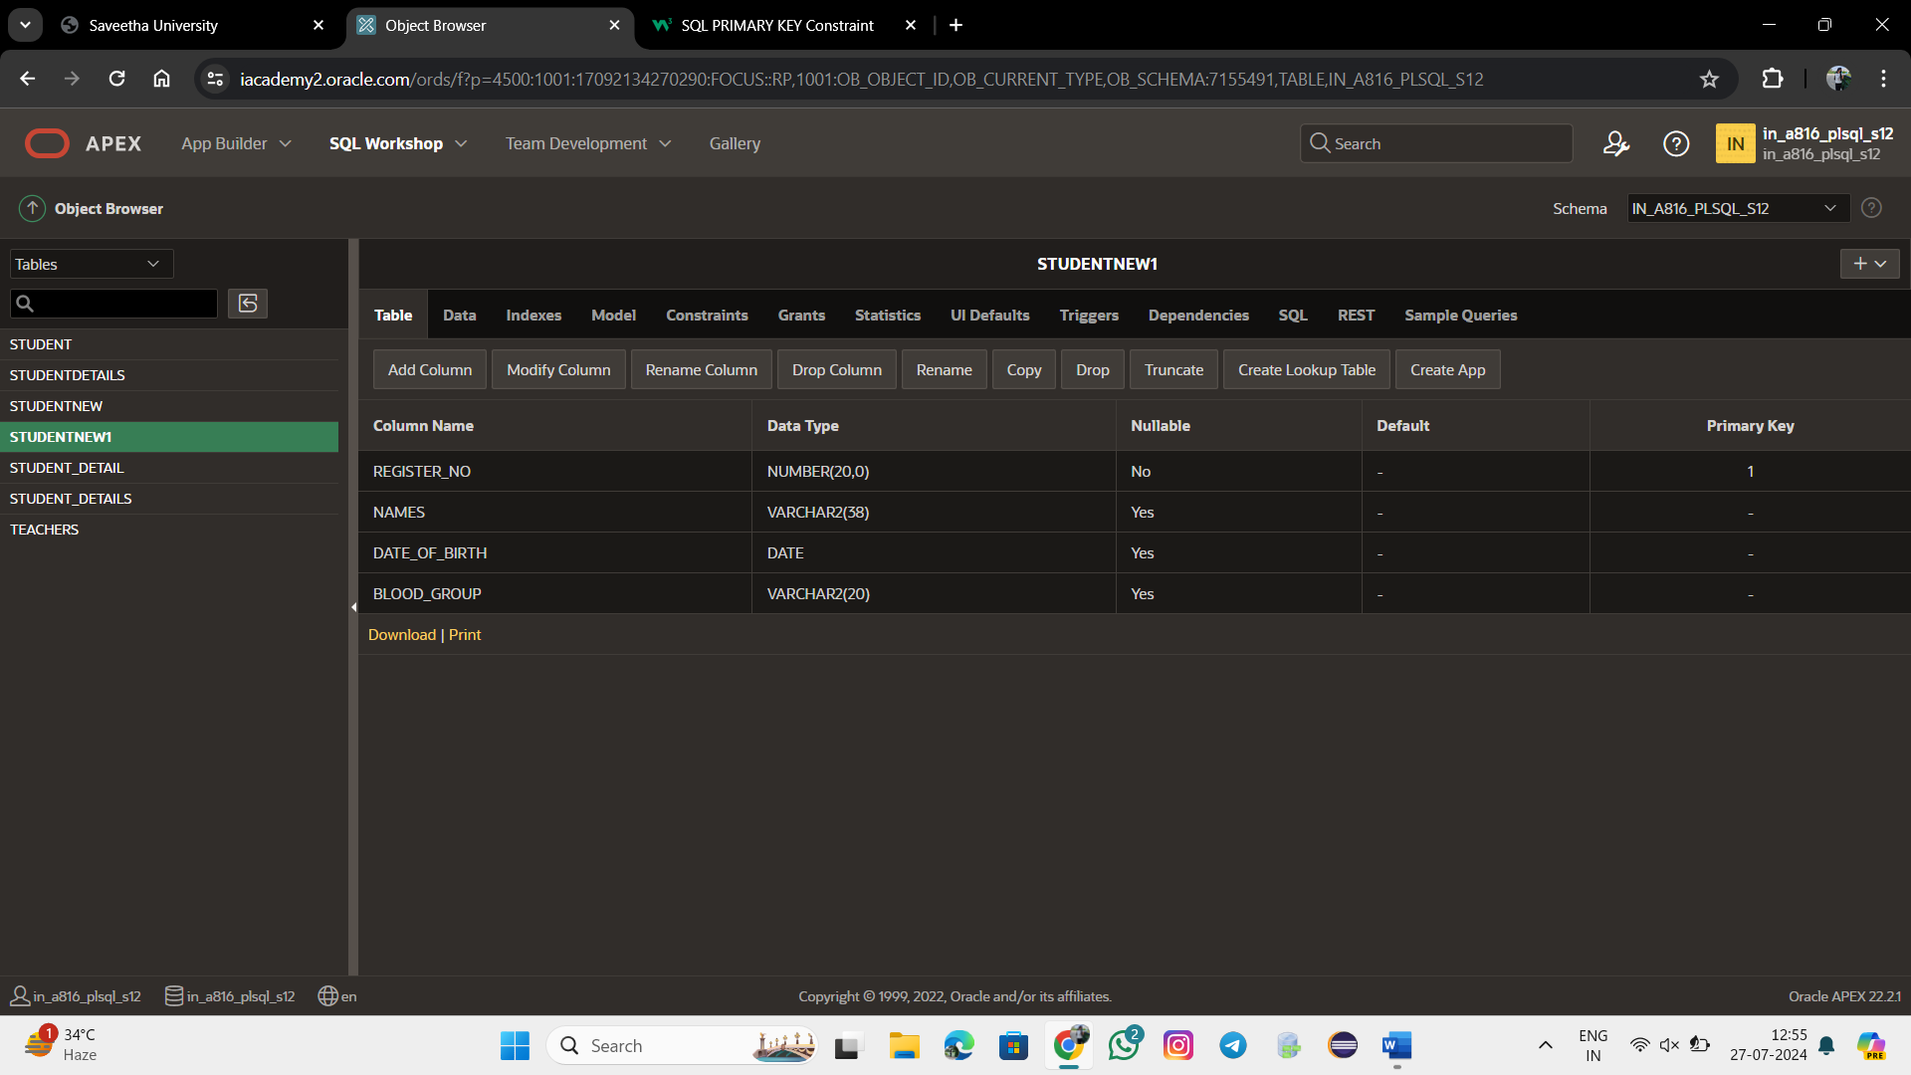

ALTER TABLE STUDENTNEW1

MODIFY Names VARCHAR(38) NOT NULL;

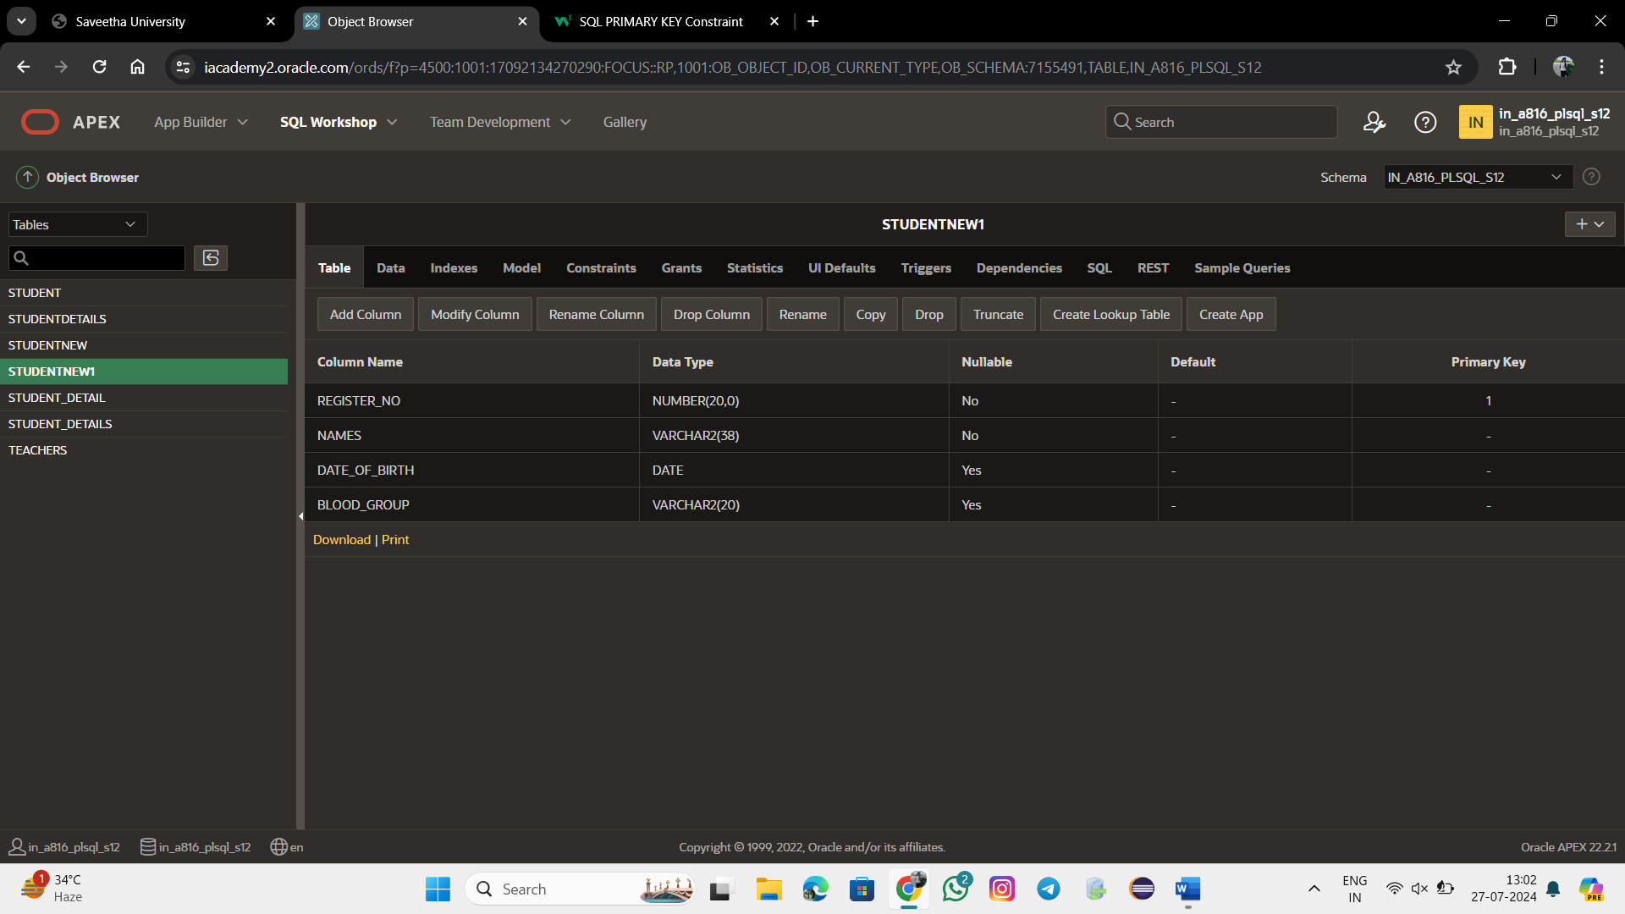

ALTER TABLE STUDENTNEW1

MODIFY Date_Of_Birth NUMERIC NOT NULL ;

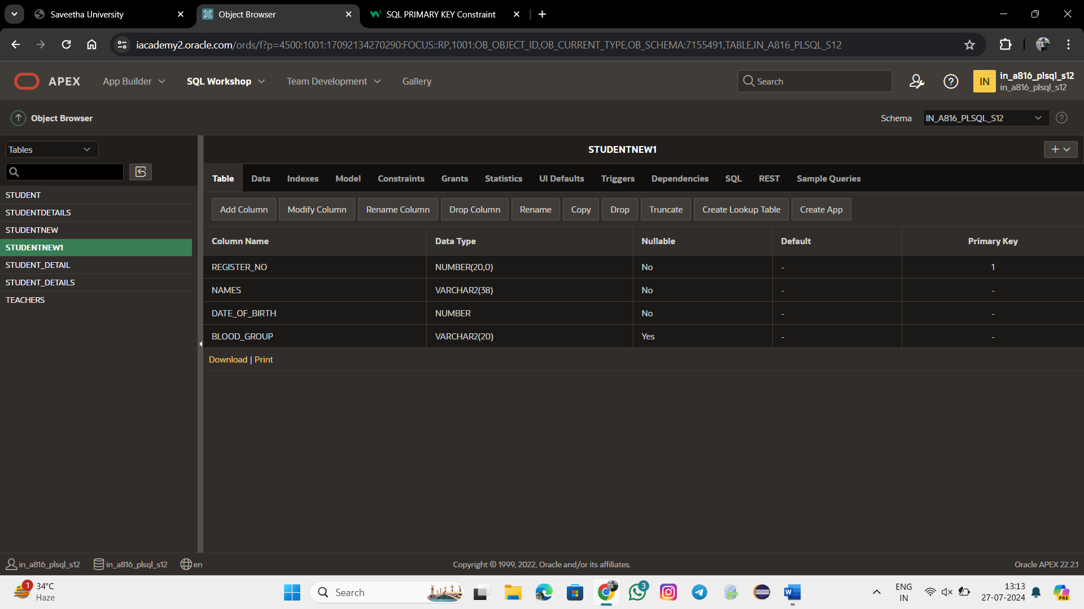

INSERT INTO STUDENTNEW1 VALUES(192321113,'Sarshini',2005,'A');

INSERT INTO STUDENTNEW1 VALUES(192321115,'Meshalisurya',2005,'0');

INSERT INTO STUDENTNEW1 VALUES(192321111,'Sugin',2006,'B');

INSERT INTO STUDENTNEW1 VALUES(192321105,'Vimal',2005,'O');

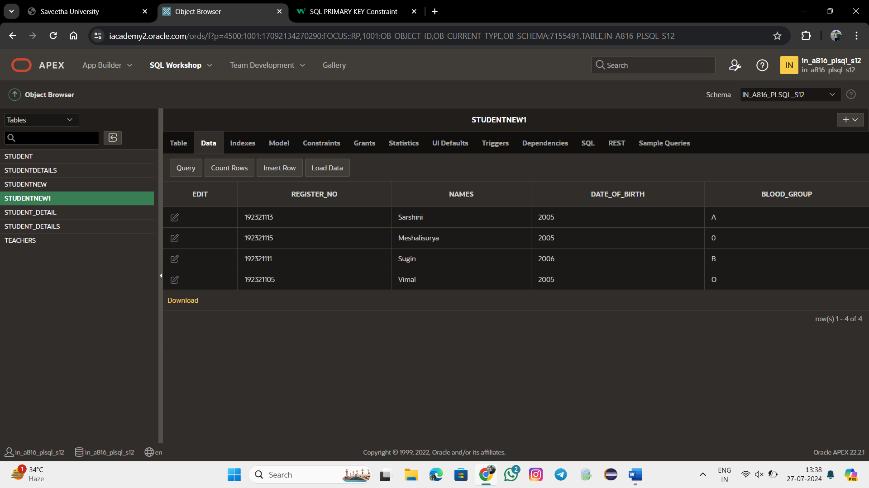

SELECT * FROM STUDENTNEW1

ORDER BY Register_No;

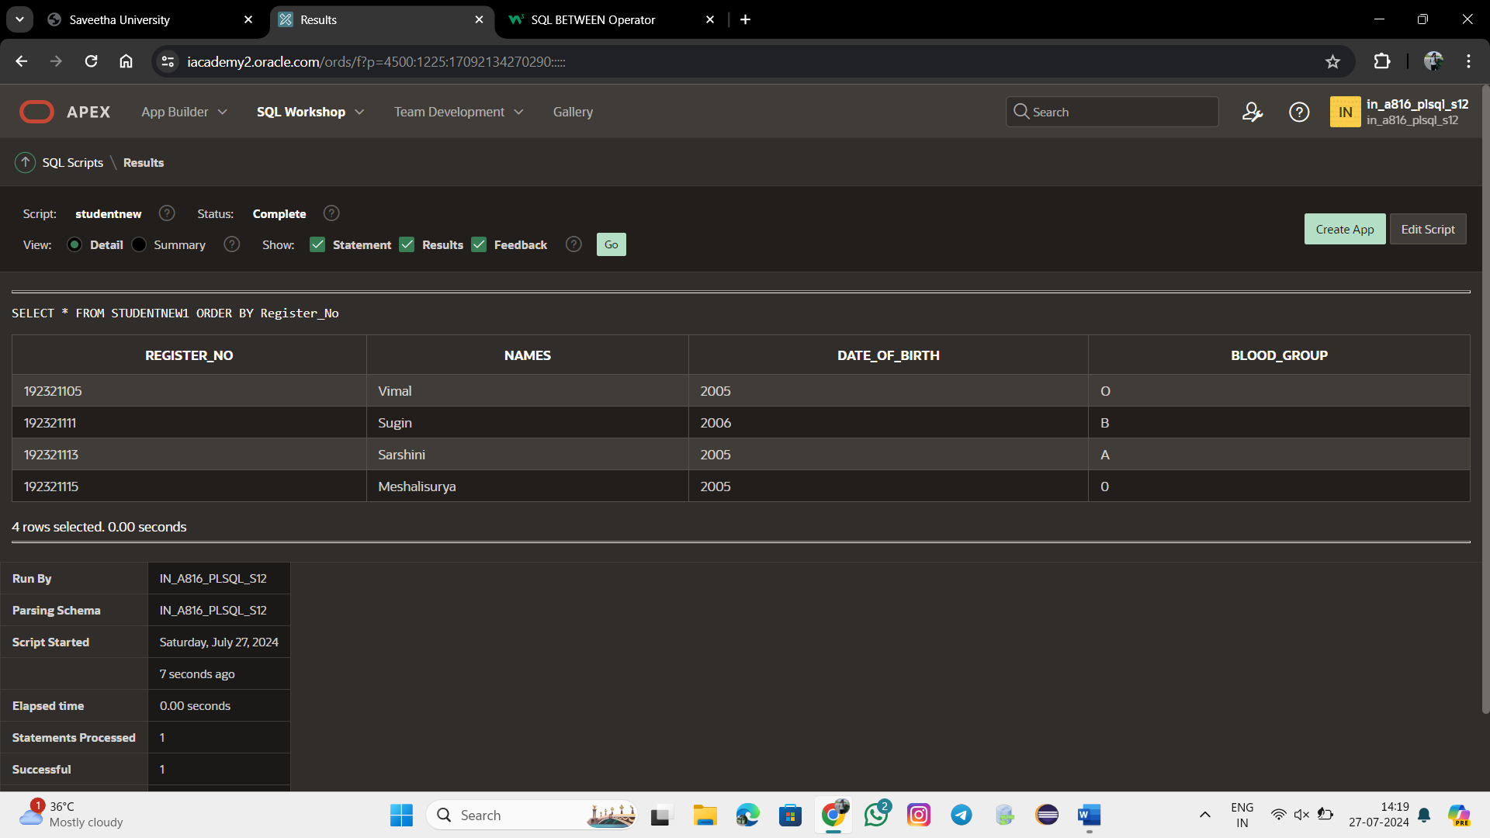

SELECT * FROM STUDENTNEW1

WHERE Register_No BETWEEN 192321113 AND 192321115;

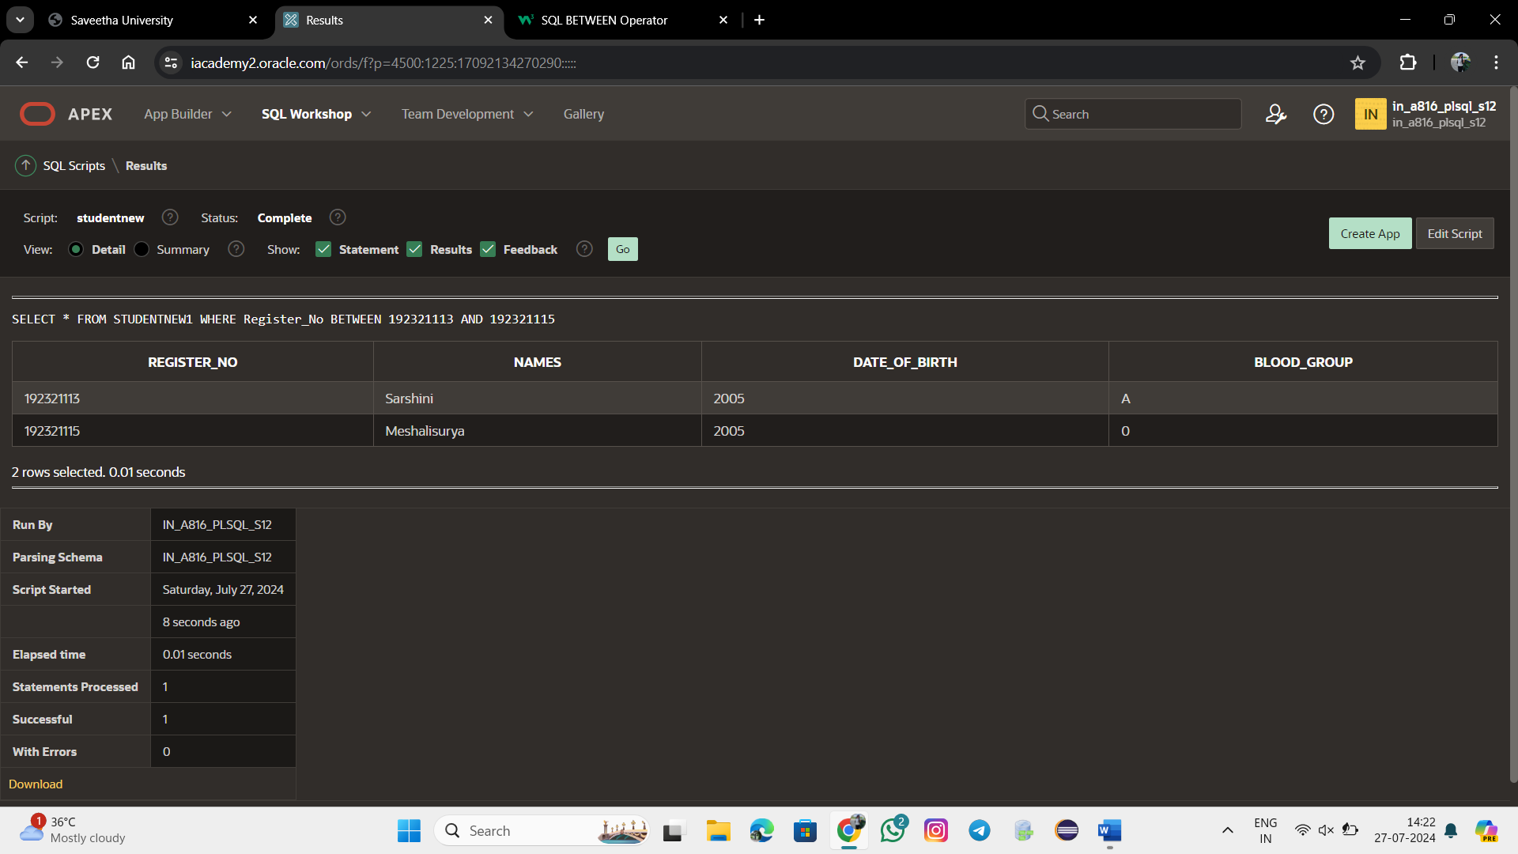

DELETE FROM STUDENTNEW1

WHERE Blood_Group ='0';

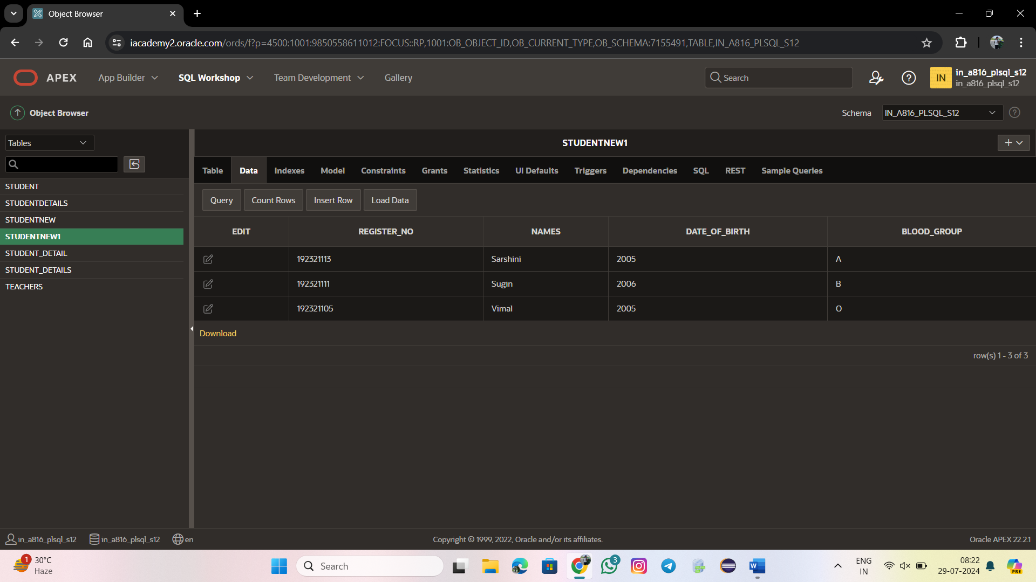

DELETE FROM STUDENTNEW1;

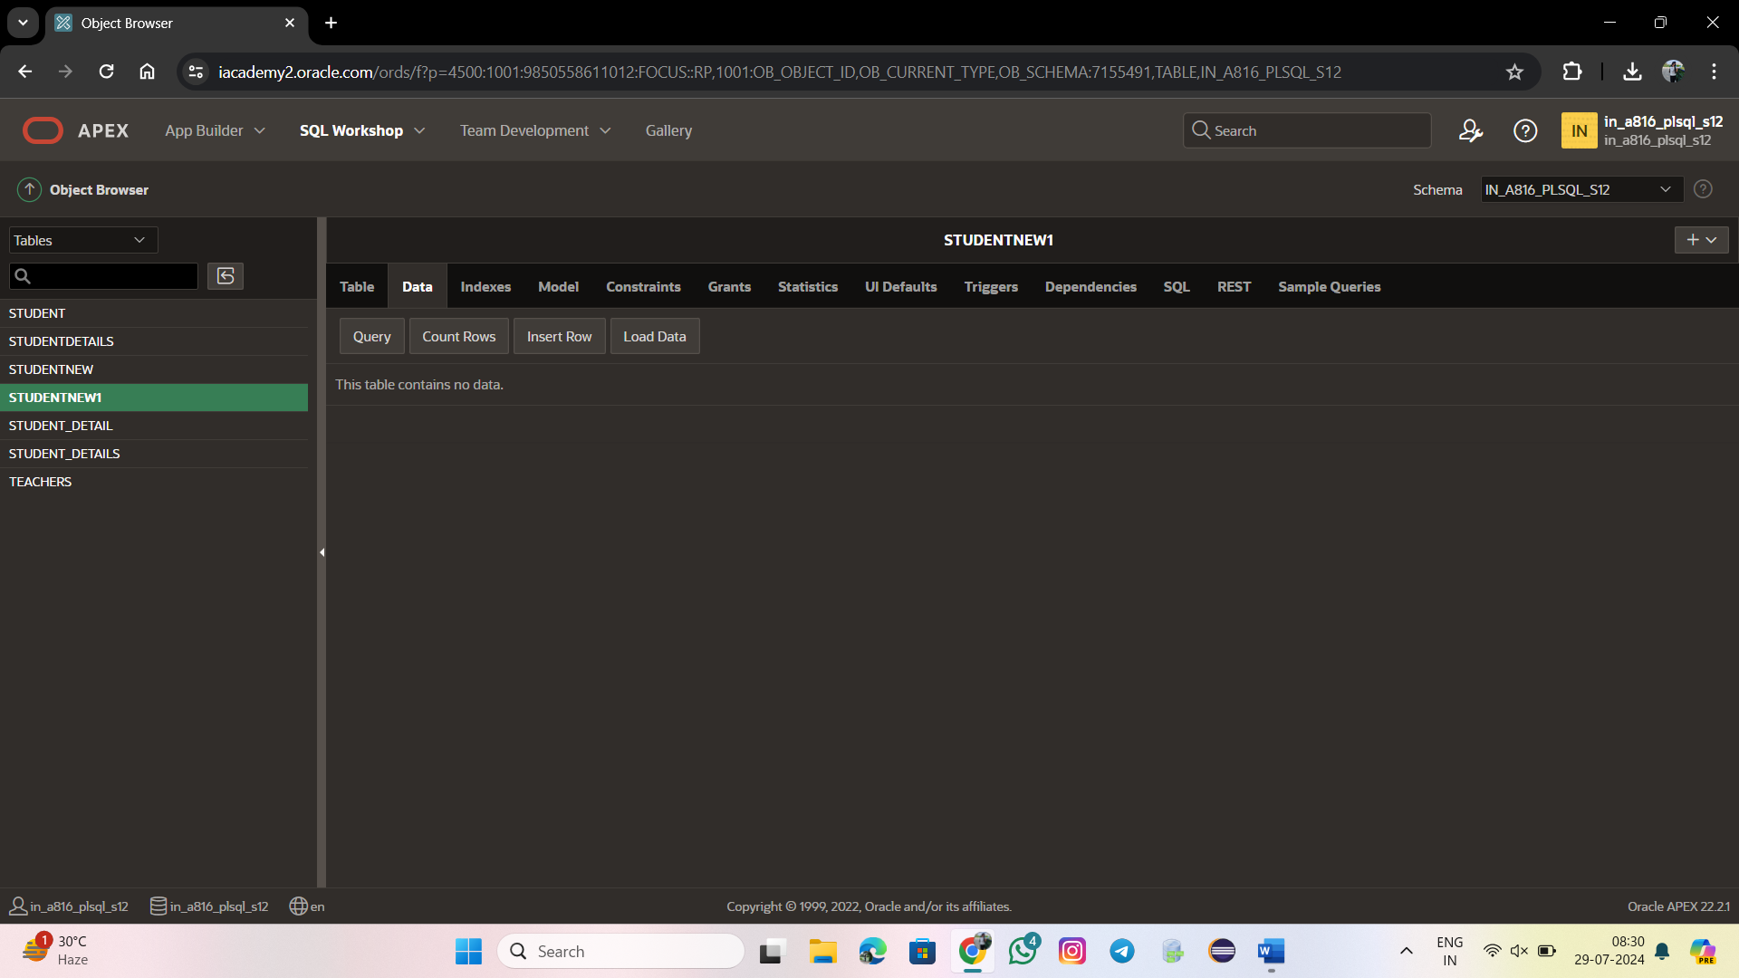

AND :

SELECT Register_No, Date_Of_Birth

FROM STUDENTNEW1

WHERE Register_No >192321111 AND Date_Of_Birth >2005;

NOT IN:

SELECT Register_No, Blood_Group

FROM STUDENTNEW1

WHERE Register_No NOT IN (192321113,192321115);

USING ||:

SELECT First_Name || Last_Name FROM STUDENTNEW1;

AS NAMES:

SELECT First_Name || Last_Name AS Names FROM STUDENTNEW1;

LIKE:

SELECT First_Name

FROM STUDENTNEW1

WHERE First_Name LIKE '% 0%';

Alter table Order1

ADD FOREIGN KEY(Person_Id) REFERENCES PERSON(Person_Id);

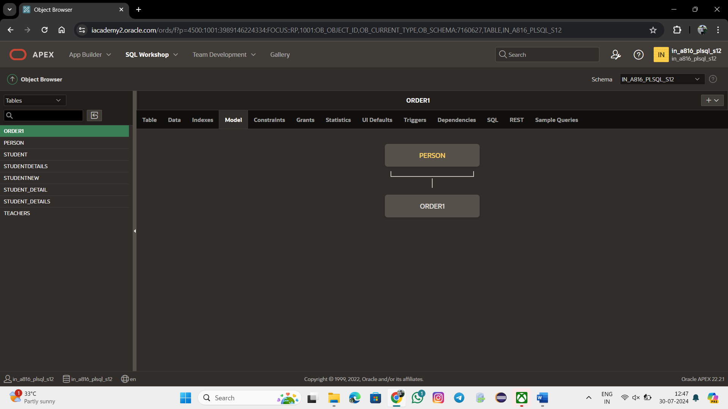

SELECT Last_name,

CASE Department_id

WHEN 90 THEN 'Management'

WHEN 80 THEN 'Sales'

WHEN 60 THEN 'It'

ELSE 'Other dept.'

END AS "Department"

FROM EMPLOYEES;

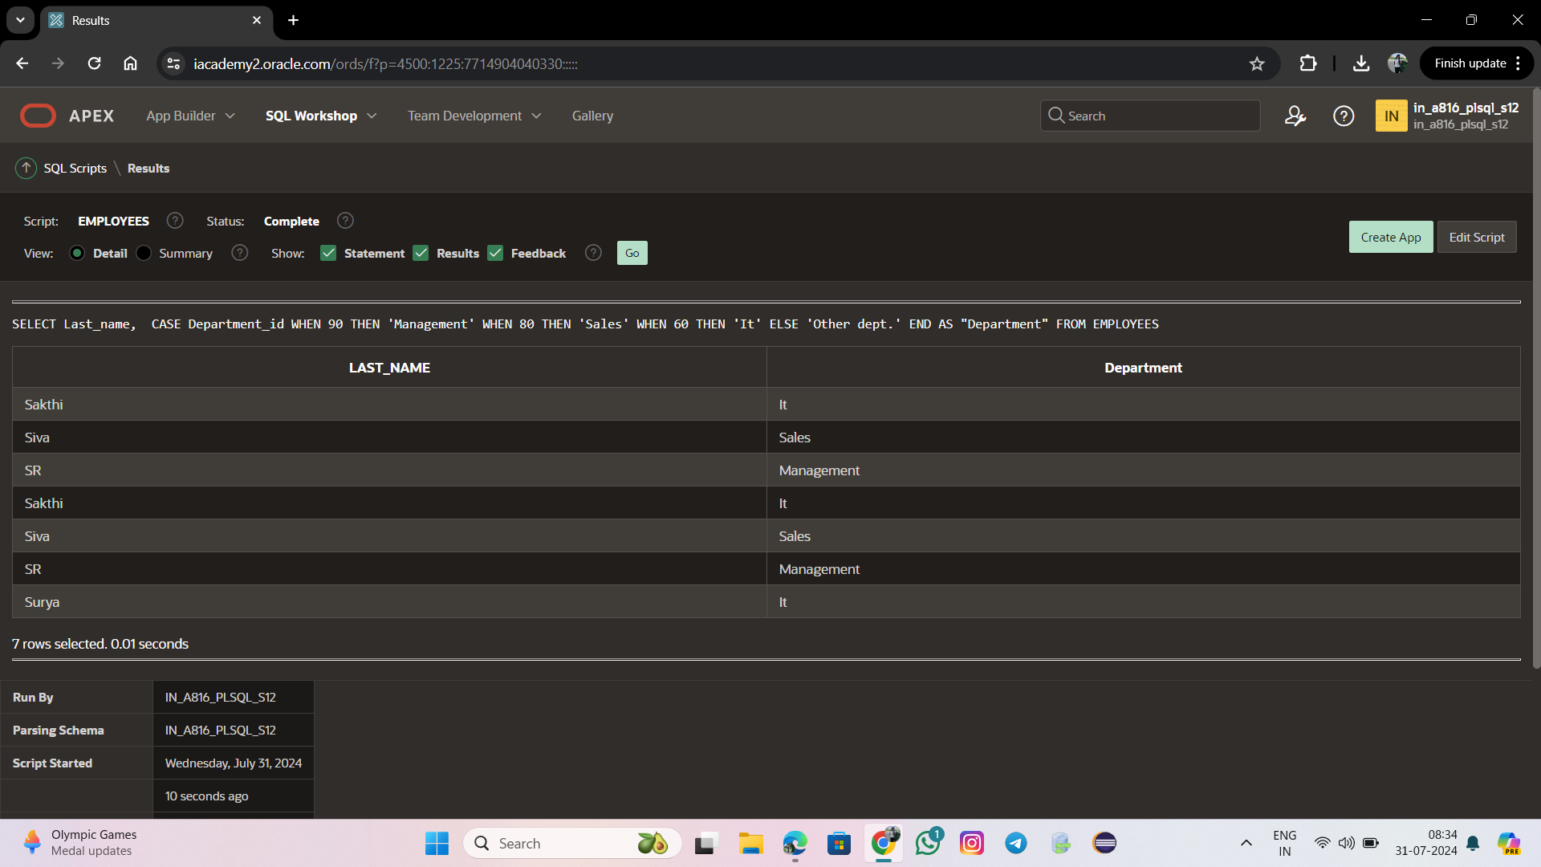

SELECT Last_name,

DECODE(Department_id,

90, 'Management',

80, 'Sales',

60, 'It',

'Other dept.')

AS "Department"

FROM EMPLOYEES;

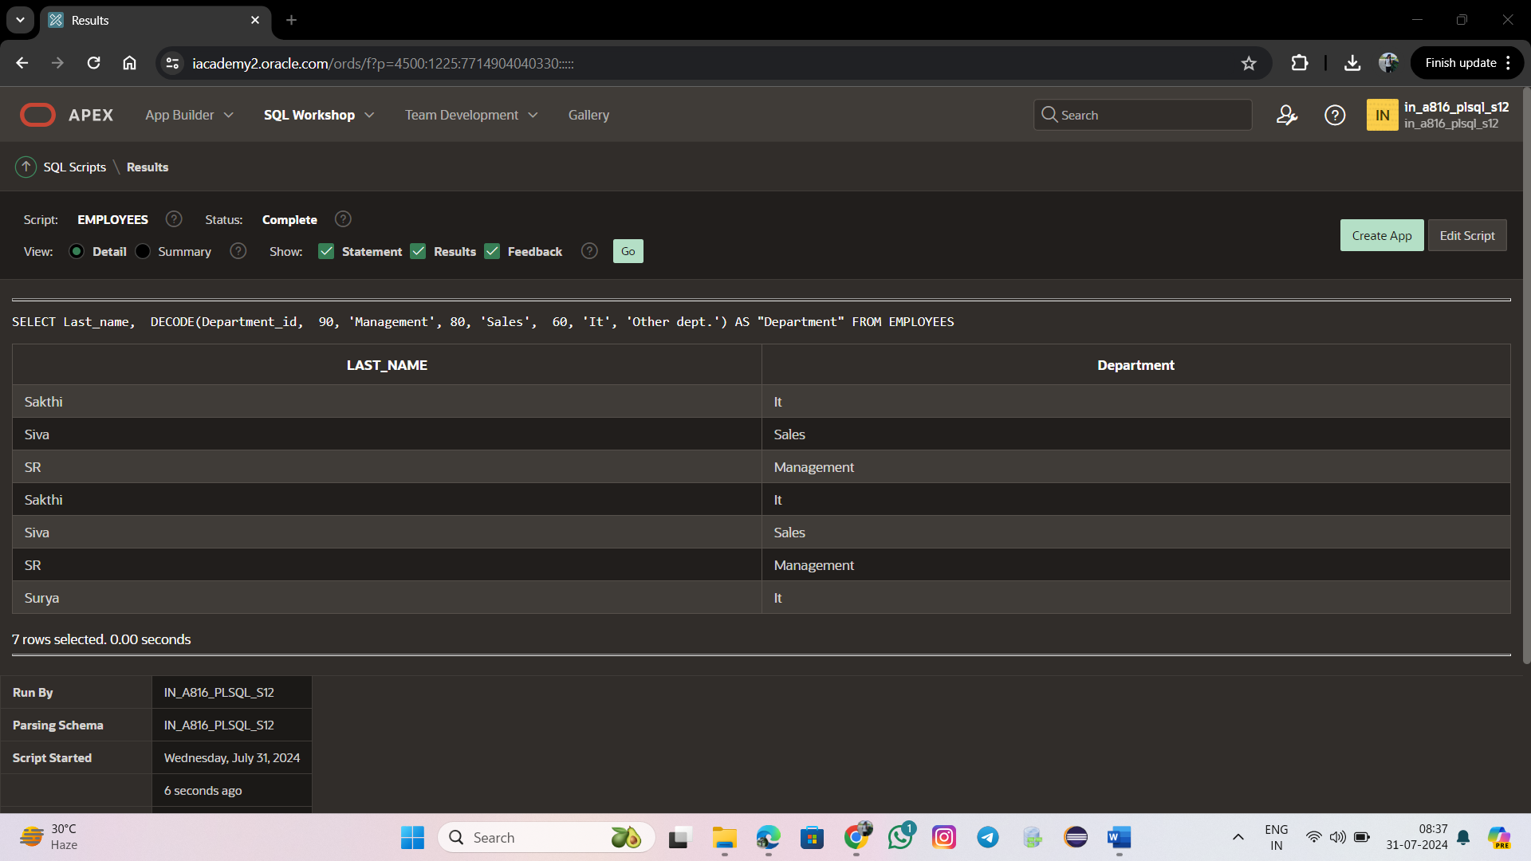

SELECT First_name, Last_name, Employee_id

FROM EMPLOYEES NATURAL JOIN jobs

WHERE Department_id > 80;

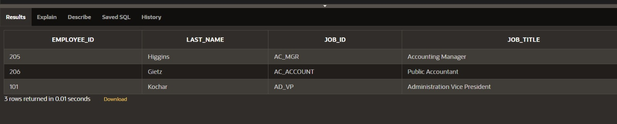

SELECT ORDERS.OrderID, PERSON.PersonID, PERSON.PersonName, PERSON.PersonAGE

FROM ORDERS JOIN PERSON ON ORDERS.PersonID = PERSON.PersonID;

SELECT FIRST_NAME ,LAST_NAME,DEPARTMENT_ID,DEPARTMENT_NAME FROM EMPLOYEE3 JOIN DEPARTMENT3 USING (DEPARTMENT_ID)

WHERE LAST_NAME ='SR';

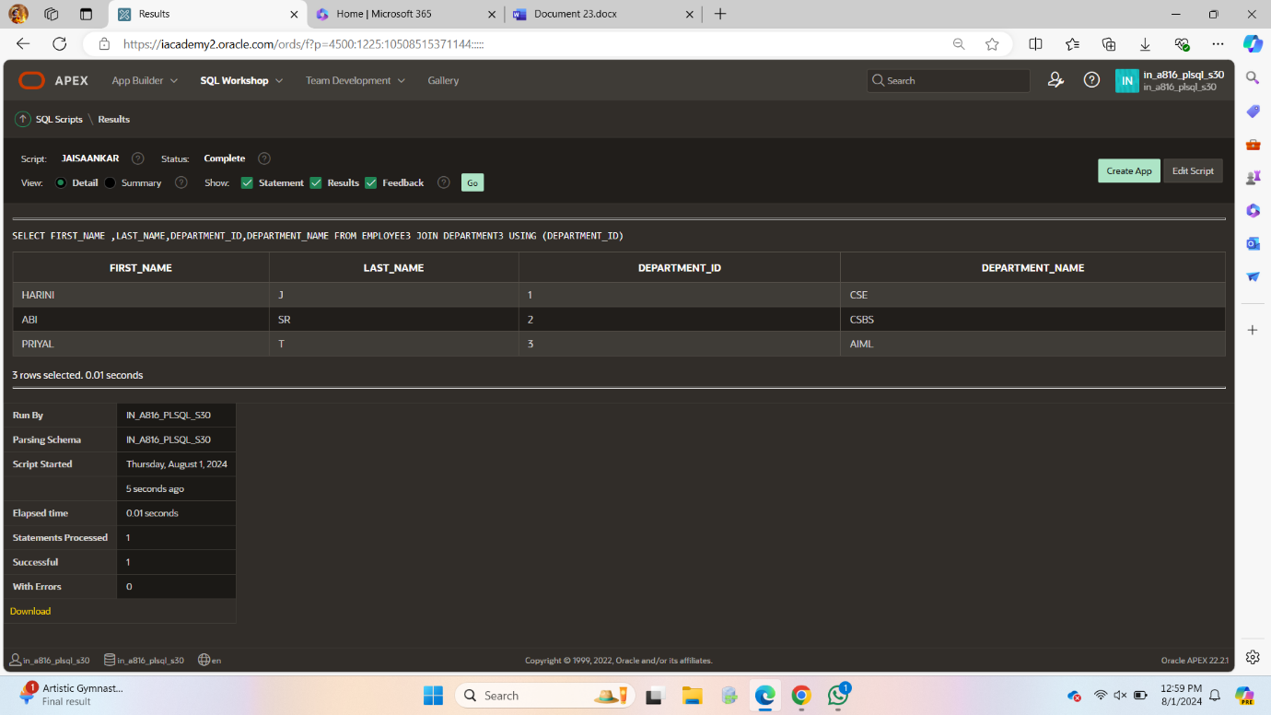

SELECT FIRST_NAME ,LAST_NAME,DEPARTMENT_ID,DEPARTMENT_NAME FROM EMPLOYEE3 JOIN DEPARTMENT3 USING (DEPARTMENT_ID);

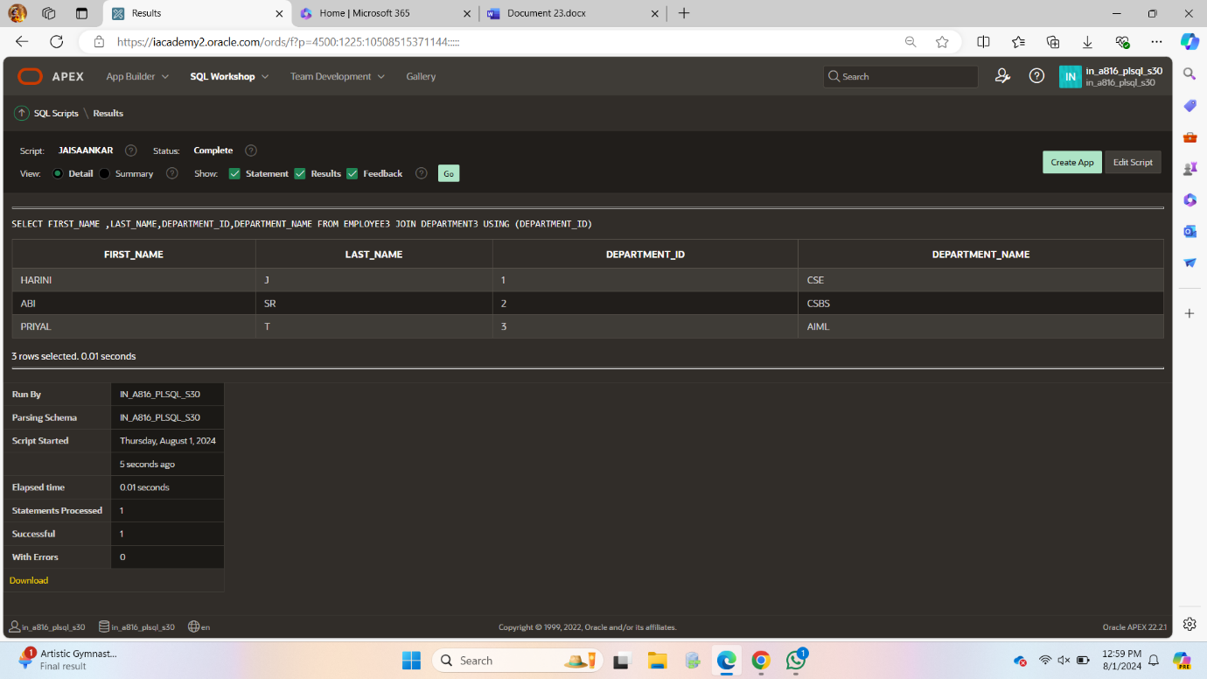

SELECT O.ORDER_ID,P.PERSON_ID,P.PERSON_NAME

FROM ORDER1 O LEFT OUTER JOIN

PERSON P

ON(O.PERSON_ID=P.PERSON_ID);

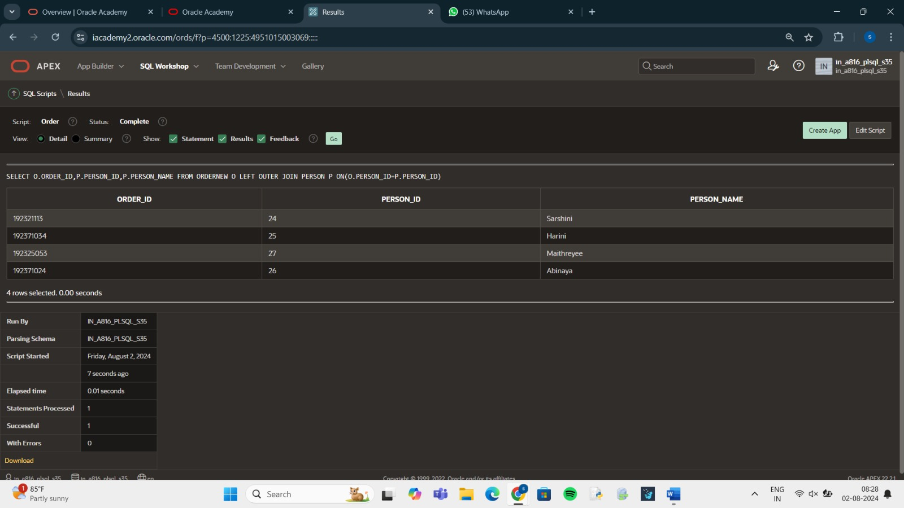

SELECT O.ORDER_ID,P.PERSON_ID,P.PERSON_NAME

FROM ORDER1 O RIGHT OUTER JOIN

PERSON P

ON(O.PERSON_ID=P.PERSON_ID);

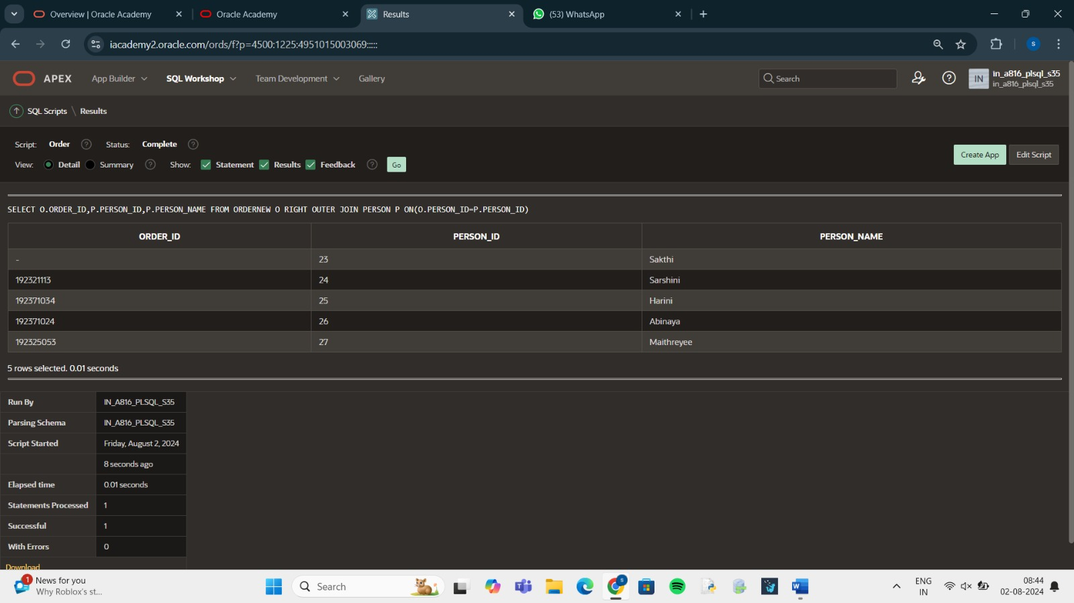

SELECT FIRST_NAME,LAST_NAME,DEPARTMENT_NAME

FROM EMPLOYEE3 CROSS JOIN

DEPARTMENT3;

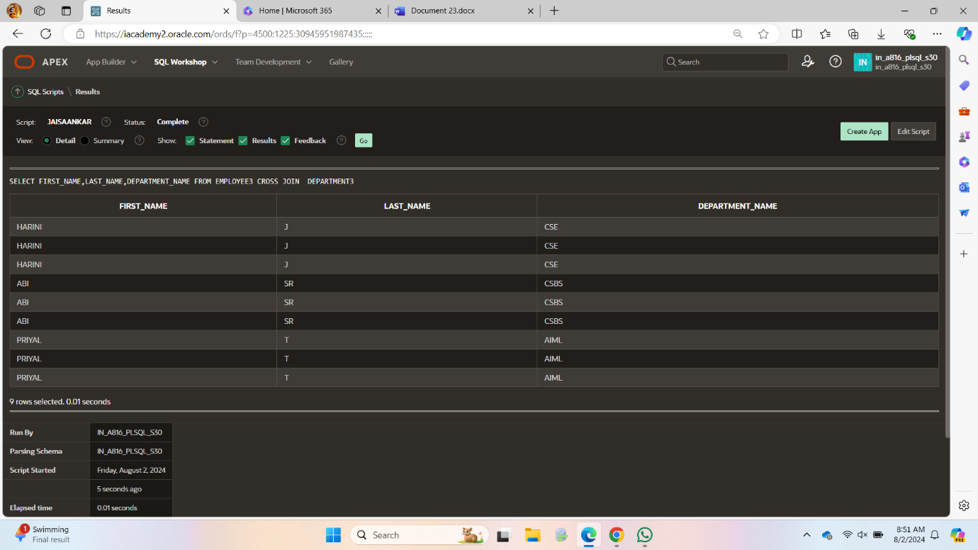

SELECT e.FIRST_NAME||'workfor'||d.FACULTY_NAME

AS " Worksfor "

FROM EMPLOYEE3 e JOIN

DEPARTMENT3 d ON (e.DEPARTMENT_ID=d.DEPARTMENT_ID);

